1. Submit Feedback (Diagram 6.1 Version 1.0 11/24/2015):

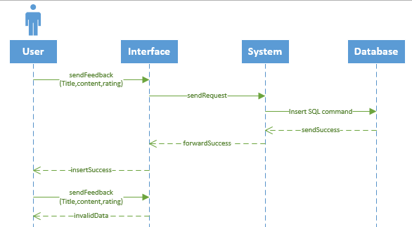

## View Feedback (Diagram 6.2 Version 1.0 11/24/2015):

